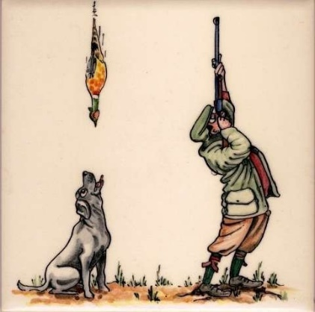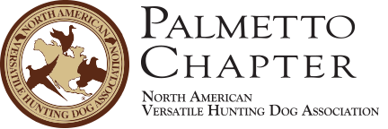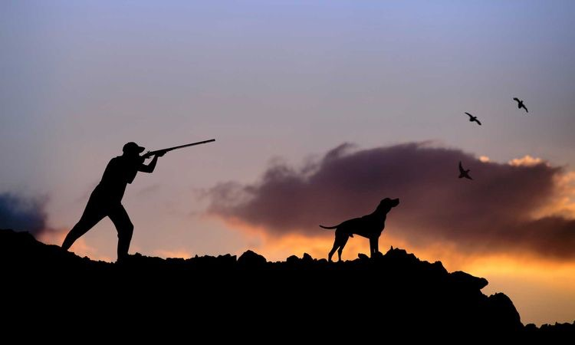

•  September 7, 2019 Saturday

•  $150 for the day, gives NRA RSO certificate

•  8am start time

•  Lunch provided

•  Skeet/Trap after class

• Host site:

**Indian Hammock Hunt and Riding Club, 32801 US Highway 441 North, Okeechobee FL 34972**

The purpose of this class is to offer our chapter’s gunners’ and members the opportunity to develop a safe environment in which to train and test their dogs and enjoy their day without any safety concerns knowing our gunners are the best around by becoming RSO certified.

Please join us for a fun day of learning to becoming a safer gunner!

## Who is invited?

Gunners interested in gunning at NAVHDA events

Q: What are the requirements?

A: International NAVHDA members that love to shoot!

Q: Where can I sign up?

A: Email Melody to register: **ThreeGSPSrGR8@hotmail.com** and **go to the Palmetto’s store to pay for registration**

**RANGE SAFETY OFFICER TRAINING AND CERTIFICATION CLASS**

# JOIN US FOR RANGE SAFETY TRAINING AND CERTIFICATION CLASS

GUNNERS

SAVE THE DATE:

SEPT 7th, 2019

**For the Love of the hunt!**